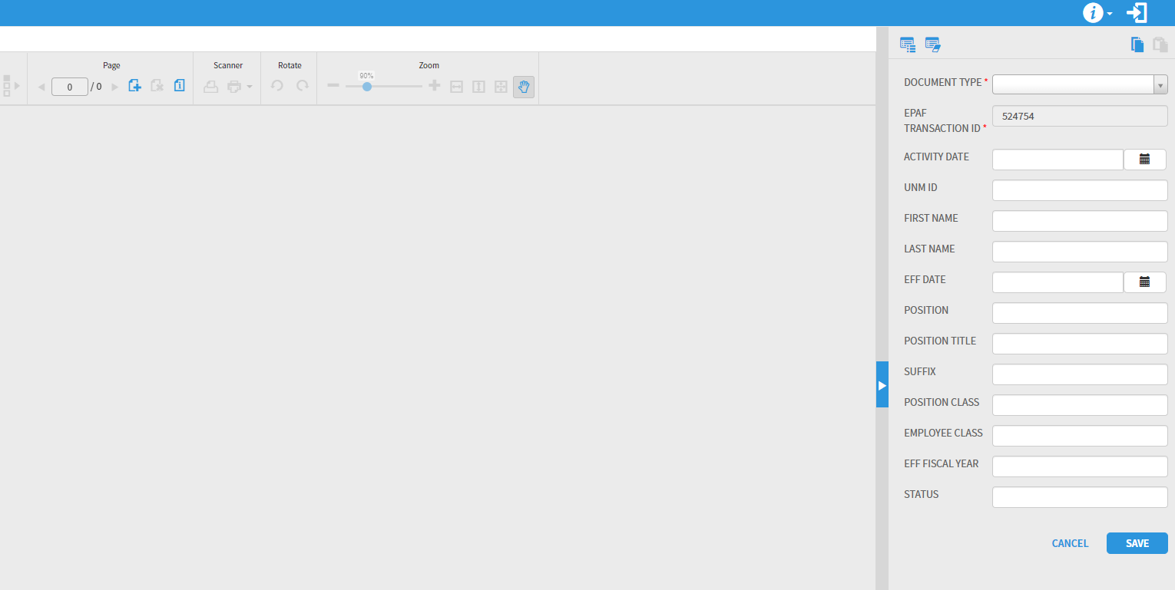

1. Drag and drop your PDF document here.

2. Select the appropriate document type from the Document Type drop down menu. You don’t have to enter any other information.

3. Click Save